Hunting with Splunk (Lab 4)

LAB 17.4

Scenario
The IT Security manager has simulated malicious activity and has asked you to create hunting detection techniques for all of it.
Sysmon and PowerShell logs are available for this task.

Goals
The learning objective of this lab is the rule generation ability and becoming more familiar with Splunk.

What you will learn
You will learn how to utilize available logs to detect suspicious activity on a windows host.

Recommended tools
- Splunk
- Use Firefox browser to connect to Splunk's web interface (http://demo.ine.local:8000)

Tasks

Task 1. Hunt for WMI Persistence
Study and research the technique described at T1084 and perform a hunt for it.
Hint: Refer to the below Sigma rule to give you an idea of how to construct a Splunk search that can detect WMI-based persistence.
https://github.com/Neo23x0/sigma/blob/master/rules/windows/sysmon/sysmon_wmi_event_subscription.yml

Task 2. Hunt for Logon Scripts
Study and research the technique described at T1037 and this additional resource, and perform a hunt for it.
Divide the task into 2 subcategories:
​ a. Hunting for logon scripts through process creation (if it has been executed)
​ b. Hunting for logon scripts through registry addition/modification (if it has been configured)
Hints: Refer to the below Sigma rule to give you an idea of how to construct the related Splunk search
https://github.com/Neo23x0/sigma/blob/master/rules/windows/sysmon/sysmon_logon_scripts_userinitmprlogonscript.yml
Sysmon Event IDs (related to registry activity) 11, 12, 13 and 14 can also help in this hunt.

Task 3. Hunt for Renamed PowerShell
Study and research the technique described at T1036 (Masquerading) and perform a hunt for it.
Hint: Refer to the below Sigma rule to give you an idea of how to construct the related Splunk search.
https://github.com/Neo23x0/sigma/blob/master/rules/windows/sysmon/sysmon_renamed_powershell.yml

Task 4. Hunt for PowerShell Empire
Research PowerShell Empire and create a detection rule that will discover its usage (focus on detecting the stager).
Hint: Focus on PowerShell logs for this hunt. To detect PowerShell Empire, create a detection rule that looks for any of the following 3 strings:
- $psversiontable.psversion.major
- system.management.automation.utils
- system.management.automation.amsiutils
Then, perform simple deobfuscation on the captured command and look for the occurrence of any of the following 5 strings:
- EnableScriptBlockLogging
- Enablescriptblockinvocationlogging
- cachedgrouppolicysettings
- ServerCertificateValidationCallback
- expect100continue

Task 5. Hunt for Unmanaged PowerShell
Perform a hunt for Unmanaged PowerShell, which was discussed in the course materials.
Hint: As discussed in the course material unmanged PowerShell can be detected by looking at the Host Application when PowerShell starts and filtering the "known goods" such as PowerShell.exe.

Task 6. Hunt for PowerShell Base64 encoded commands
Research on PowerShell abuse and define a rule which detects the usage of obfuscated malicious commands in the available PowerShell logs.
Hint: Use Sysmon event ID 1, looking for command line arguments that would match those of an encoded command. The Hunting with ELK labs include all the information you need to hunt for Base64-encoded PowerShell code.

Task 7. Hunt for lateral movement through admin shares
Study and research the technique described at T1077 Admin Shares and perform a hunt for it.
Hint: Common tools that abuse admin shares is some of PSExec's implementations - such as the one in Cobalt Strike. A distinctive characteristic is the connection back to the ADMIN$ share on localhost at 127.0.0.1 to execute a binary file which runs rundll32.exe.

Task 8. Hunt for download of word documents
Utilizing the available logs, create a Splunk detection search that detects downloaded word documents, which may be suspicious.
Note - For this hunt, focus on the extension ".doc" only.
Hint: To identify downloaded files, you can utilize the fact that Windows sets alternate data streams "Zone.Identifier" to recognize web content and alert the user of potentially dangerous file. To detect that, use Sysmon ID 15 - FileCreateStreamHash.

Task 9. Hunt for malicious Word document
Study and research the technique described at T1064 Scripting and perform a hunt for it.
Hint: Hunt for processes that were spawned by winword.exe

Task 10. Hunt for persistence in Registry Run keys
Study and research the technique at T1060 and perform a hunt for it.
Hint: Focus on Sysmon Event ID 13, and also on activity associated with the registry path "*\Windows\CurrentVersion\Run*".

Task 11. Hunt for Filesystem persistence
Study and research the technique at T1060 (Startup folder) and perform a hunt for it.
Hint: Hunt for processes started in the Startup location.

Task 12. Hunt for internal recon
Study and research the technique here and perform a hunt for it.
Hint: Hunt for 2 or more binaries that can be used for reconnaissance (whoami.exe, netstat.exe, etc.) that were executed within a timeframe of 15 minutes.

Task 13. Hunt for suspicious VBS scripts
Study and research the technique described at T1064 Scripting and perform a hunt for it.
Hint: Focus on Sysmon event ID 1 to identified execution of cscript.exe or wscript.exe.

SOLUTIONS
Below, you can find solutions for each task. Remember though, that you can follow your own strategy, which may be different from the one explained in the following lab.

Task 1. Hunt for WMI Persistence
After researching through the provided technique and some of the references, including the proposed detection rule in Sigma, it appears that WMI persistence can be discovered by looking at WMI events that Sysmon captures in Event IDS 19, 20 and 21. With that in mind, we can perform a search for those events and display back to us concrete information if those events had occurred, such as what file is to be started. The final query we construct is:
index=winsysmon EventCode=19 OR EventCode=20 OR EventCode=21 | table _time, EventCode, EventDescription, Operation, Computer, Consumer, Query, Destination
Once the query is executed, we get the following match:
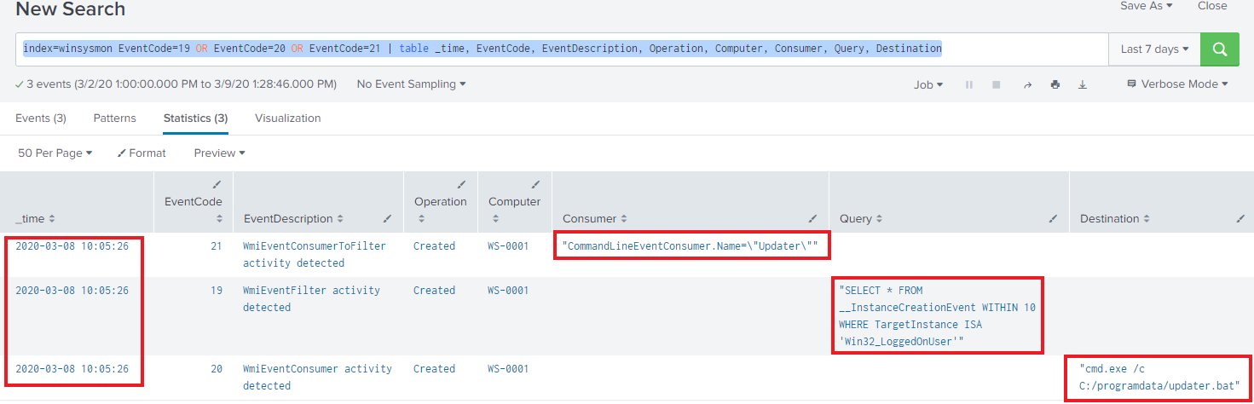
It appears that a new activity was observed, with the name "Updater", that triggers on the login of any users and executes the command "cmd.exe /c C:/programdata/updater.bat".

Task 2. Hunt for Logon Scripts
a. Hunting for logon scripts through process creation
After researching provided resources, we discover that logon scripts are started by "userinit.exe". A detection rule is also provided in Sigma, which we can utilize to construct the following query:
index=winsysmon ((ParentImage="*\\userinit.exe" NOT (Image="*\\explorer.exe")) NOT ((CommandLine="*\\netlogon.bat" OR CommandLine="*\\UsrLogon.cmd"))) | stats values(cmdline) dc(Computer) AS hosts count by ParentImage Image
Once executed, we get the following match:
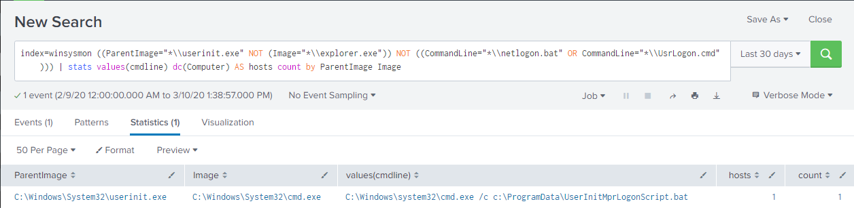
A logon script was executed on 1 host and the running image with its command line argument are present to reveal that batch script was executed in %ProgramData%.
b. On the second hunt, utilizing the previously mentioned Sigma rule, we observe that Sysmon Event IDs (related to registry activity) 11, 12, 13 and 14 can be monitored if they had captured any activity towards the key UserInitMprLogonScripts. We therefore construct the following query:
index=winsysmon ((EventCode="11" OR EventCode="12" OR EventCode="13" OR EventCode="14") AND TargetObject="*UserInitMprLogonScript*") | table Computer, EventCode, signature, TargetObject, Details
Executing the query, we'll see a match that outlines the configuration of the batch script executed in step a:
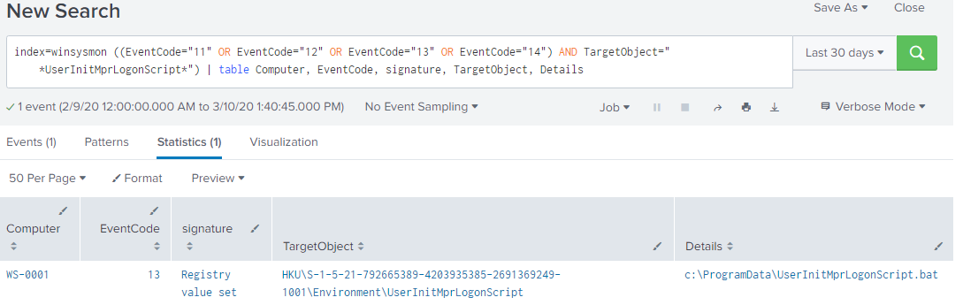

Task 3. Hunt for Renamed PowerShell
After reviewing the MITRE documentation and the following Sigma detection rule, we'll base our hunt on any started process that has description "Windows PowerShell" and is not powershell.exe or powershell_ise.exe. We then construct the following query:
index=winsysmon EventCode=1 AND Description="Windows PowerShell" AND (Image!="*\\powershell.exe" AND Image!="*\\powershell_ise.exe") | rex field=Hashes ".*MD5=(?<MD5>[A-F0-9]*)," | table _time, Computer, User, Image, cmdline, ParentImage, MD5
When executed, we get the following match:
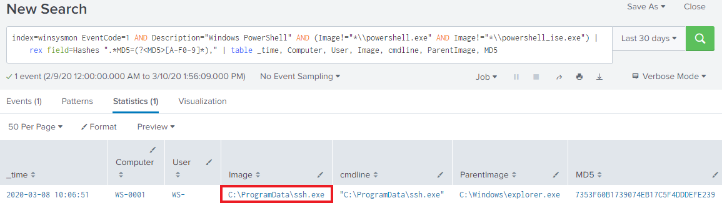
It appears that PowerShell was moved to ProgramData and renamed to "ssh.exe".
Another benefit of similar search to get a high level overview of the environment is to list all processes with description "Windows PowerShell", which will also show us the general usage of different PowerShell versions across the organization. To do that, we use the following query:
index=winsysmon EventCode=1 AND Description="Windows PowerShell" | rex field=Hashes ".*MD5=(?<MD5>[A-F0-9]*)," | stats dc(Computer) AS Hostname count by Image MD5 Description| sort -count
After we execute the query, we'll see the following outcome:
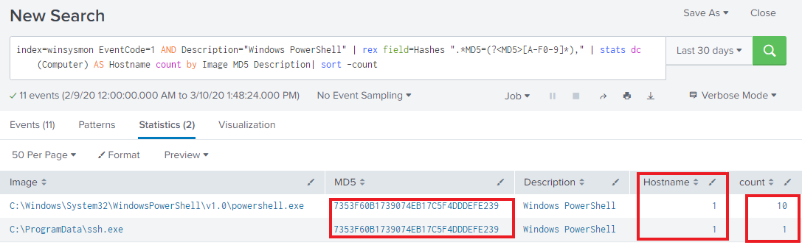
In our environment, only 1 PowerShell version has been executed, on a single host. The renamed PowerShell also appears to be the same version as the preinstalled PowerShell on the machine (although we cannot tell if it was executed for legitimate reasons in this view).

Task 4. Hunt for PowerShell Empire
As the name suggests, PowerShell Empire is using PowerShell on victim machines to run malicious activity. Since we have PowerShell logs available to us (Script-Block logging), we can use that to detect any malicious usage. Tom Ueltschi (renowned security researcher) proposed a detection rule that looks for any of the following 3 strings:
- $psversiontable.psversion.major
- system.management.automation.utils
- system.management.automation.amsiutils
Then, perform simple deobfuscation on the captured command and look for the occurrence of any of the following 5 strings:
- EnableScriptBlockLogging
- Enablescriptblockinvocationlogging
- cachedgrouppolicysettings
- ServerCertificateValidationCallback
- expect100continue
Finally, we construct the following query:
index=* EventCode=4104 AND ($psversiontable.psversion.major OR system.management.automation.utils OR system.management.automation.amsiutils) | eval MessageDeobfuscated = replace(Message, "[ `'+\"\^]","") | search EnableScriptBlockLogging OR enablescriptblockinvocationlogging OR cachedgrouppolicysettings OR ServerCertificateValidationCallback OR expect100continue | table _time ComputerName Sid MessageDeobfuscated
When executed, we get the following match:
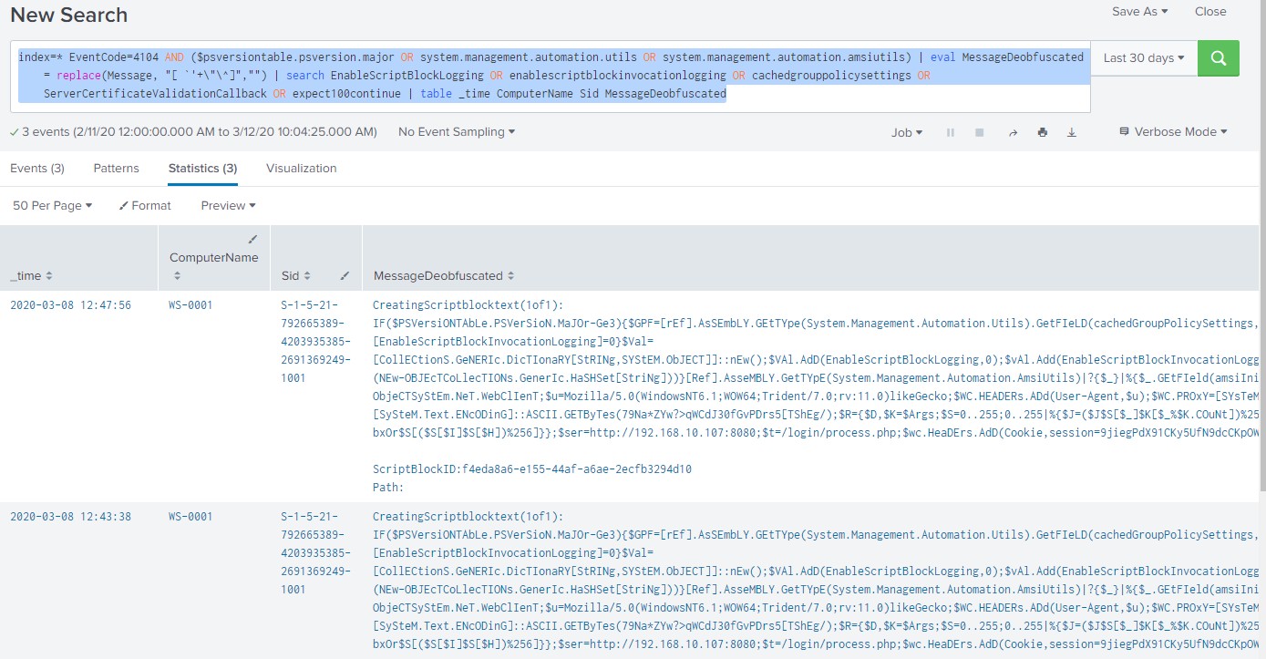
Let's look closer in the first event:
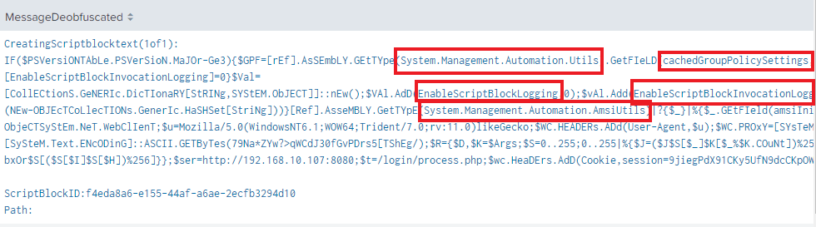

Task 5. Hunt for Unmanaged PowerShell
As described in the course materials, Unmanaged PowerShell can be detected by looking at the Host Application when PowerShell starts and filtering the "known goods" such as PowerShell.exe. We construct the following query:
index=* hostapplication | rex field=Message ".*HostApplication=(?<HostApplication>.*)" | search HostApplication!="*powershell*" HostApplication!="*\\sdiagnhost.exe*" | stats count by host HostApplication
When executed, we get the following match:
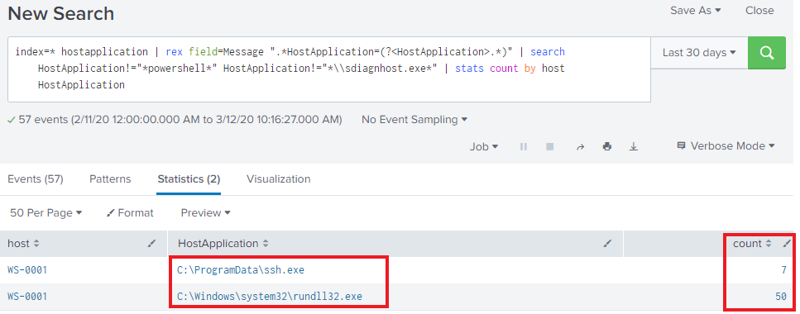
You can recall from Task 3, that we discovered ssh.exe to be an instance of renamed PowerShell.

Task 6. Hunt for PowerShell Base64 encoded commands
For this part, we'll use Sysmon event id 1, looking for command line arguments that would match those of an encoded command. The parameter that we are looking for is "-encodedcommand" but the bare minimum that PowerShell needs provided as arguments to threat it as an encoded command is simply "-e". So, let's filter out for event id 1, look for all powershell processes (powershell.exe or PowerShell in description), and parameter that contains "-e" (although we will tune this down slightly to avoid potential false positives). Initially, we'll list information related to the parent processes that were observed to be association with this activity -- the final query is shown below:
index=* EventCode=1 | eval cmdline =replace(cmdline, "-[Ee][Nn][Cc][Oo][Dd][Ii][Nn][Gg]", "__encoding") | search Image="*\\powershell.exe" (cmdline="* -enc*" OR cmdline="* -en *" OR cmdline="* -e *" OR cmdline="* -ec *") | table _time Computer User ParentImage ParentCommandLine
Once executed, we receive the following output:
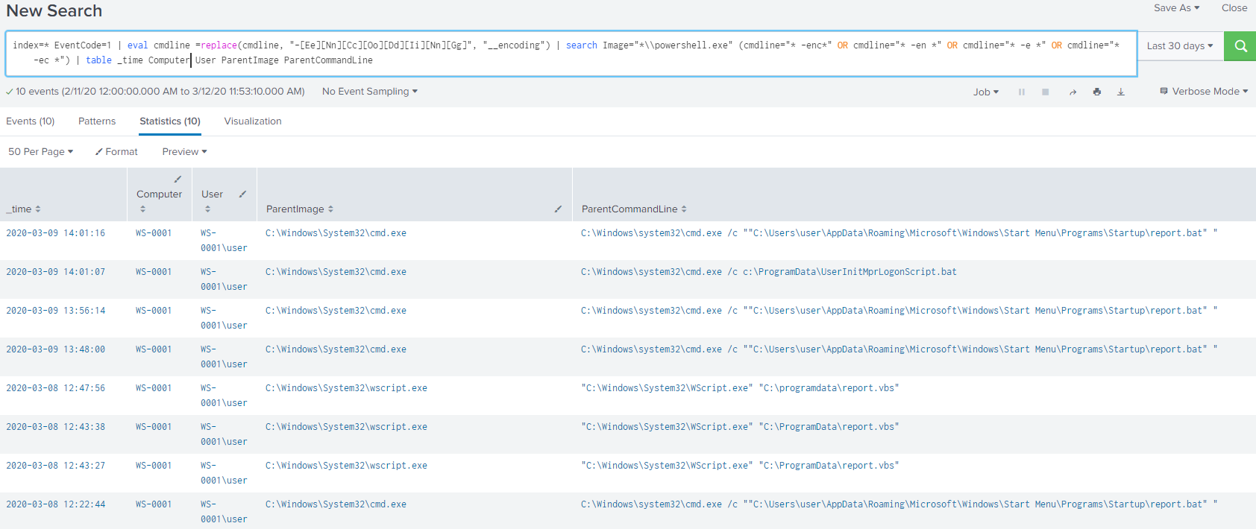
Immediately, we'll note the entry executing "c:\ProgramData\UserInitMprLogonScript.bat" which is familiar to us from Task 2. The other entries appear suspicious for many reasons but for now, we'll focus on reviewing the actual command line that was flagged. Let's modify the search:
index=* EventCode=1 | eval cmdline =replace(cmdline, "-[Ee][Nn][Cc][Oo][Dd][Ii][Nn][Gg]", "__encoding") | search Image="*\\powershell.exe"
(cmdline="* -enc*" OR cmdline="* -en *" OR cmdline="* -e *" OR cmdline="* -ec *") | table _time Computer User cmdline
Executing the query, we'll get the following match:
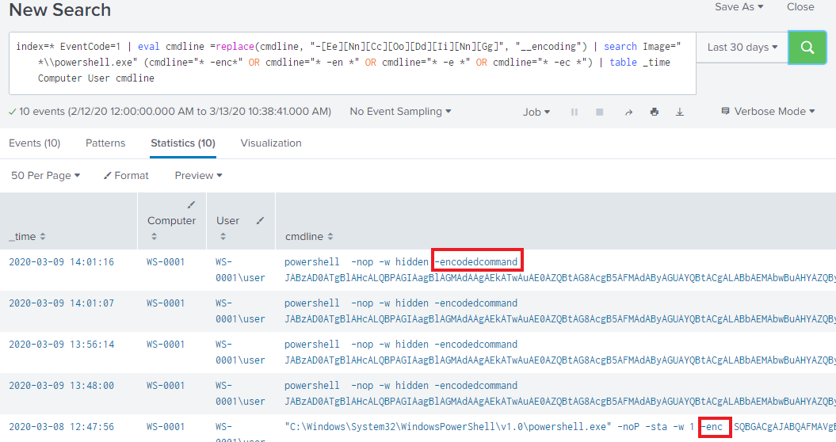

Task 7. Hunt for lateral movement through admin shares
After researching through the provided technique and some of the references, the shares that we are interested in are C$, ADMIN$, and IPC$. Common tools that abuse these shares is some of PSExec's implementations - such as the one in Cobalt Strike. A distinctive characteristic is the connection back to the ADMIN$ share on localhost at 127.0.0.1 to execute a binary file which runs rundll32.exe. Taking that into account, we create the following query:
index="winsysmon" EventCode=1 ParentImage=\\\\127.0.0.1\\ADMIN$\\*.exe AND Image=*\\rundll32.exe | table _time Computer User ParentImage Image
Once executed, we get the following output:
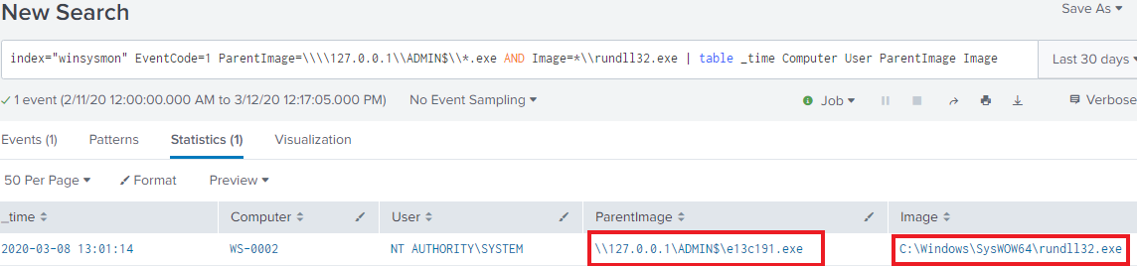

Task 8. Hunt for download of word documents
To identify downloaded files, we'll utilize the fact that Windows sets alternate data streams "Zone.Identifier" to recognize web content and alert the user of potentially dangerous file. To detect that, we'll use Sysmon ID 15 -- FileCreateStreamHash, specifically looking for files that contain ".doc". Our final query is:
index="winsysmon" EventCode=15 TargetFilename="*.doc.*" | table _time Computer Image TargetFilename MD5
Once we execute it, we get the following:
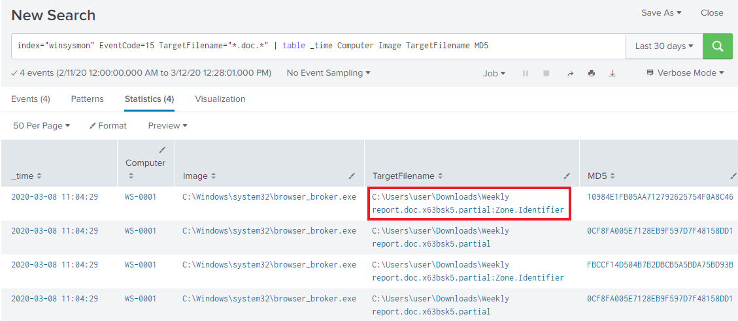
The image of browser_broker indicates that a browser downloaded the content (most likely the user visited a link).

Task 9. Hunt for malicious Word document
After reviewing the MITRE documentation and linking it to the title of task, we must be hunting for a malicious macro. Our query will simply list all processes that were spawned by winword.exe. The final constructed query is:
index="winsysmon" EventCode=1 ParentImage=*\\winword.exe | table _time Computer User Image ParentImage ParentCommandLine
Once executed, we get:
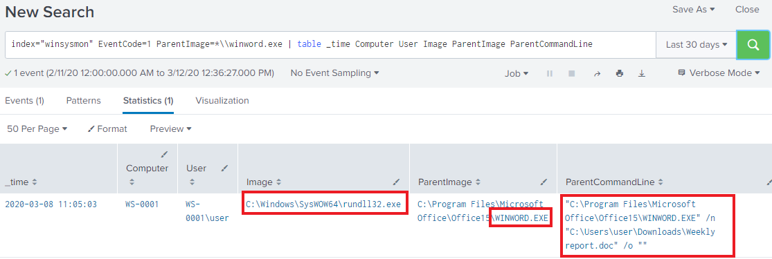
It seems that the document which was downloaded from the Internet (discovered in Task 8), was opened in Word, and spawned rundll32.exe. This is a highly suspicious activity.

Task 10. Hunt for persistence in Registry Run keys
After reviewing the MITRE documentation, our hunt will focus on Sysmon Event ID 13, and focus on activity associated with the registry path "\Windows\CurrentVersion\Run". The final query constructed is:
index="winsysmon" EventCode=13 "*\\Windows\\CurrentVersion\\Run*" | rex field=Image ".*\\\\(?<Image_EXE>[^\\\\]*)" | rex field=TargetObject ".*\\\\CurrentVersion\\\\(?<TargetObj_PATH>.*)" | strcat "Image=\"" Image_EXE "\", TargetObject=\"" TargetObj_PATH "\", Details=\"" Details "\"" Image_TargetObj_Details | stats dc(Computer) AS Clients values(Image_TargetObj_Details) count by EventDescription Image_EXE
Once executed, we get the following:
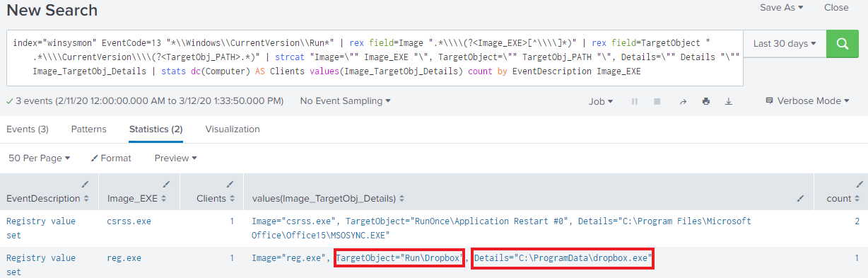
Immediately an entry stands out, which has occurred only once and executes a file in "ProgramData".

Task 11. Hunt for Filesystem persistence
After reviewing the MITRE documentation, the hunt we are performing focuses on processes started in the Startup location. We construct the following query:
index="winsysmon" EventCode=1 Image="*\\Microsoft\\Windows\\Start Menu\\Programs\\Startup\\*" OR CommandLine="*\\Microsoft\\Windows\\Start Menu\\Programs\\Startup\\*" | table _time Computer User Image CommandLine MD5
Once executed, we get the following:
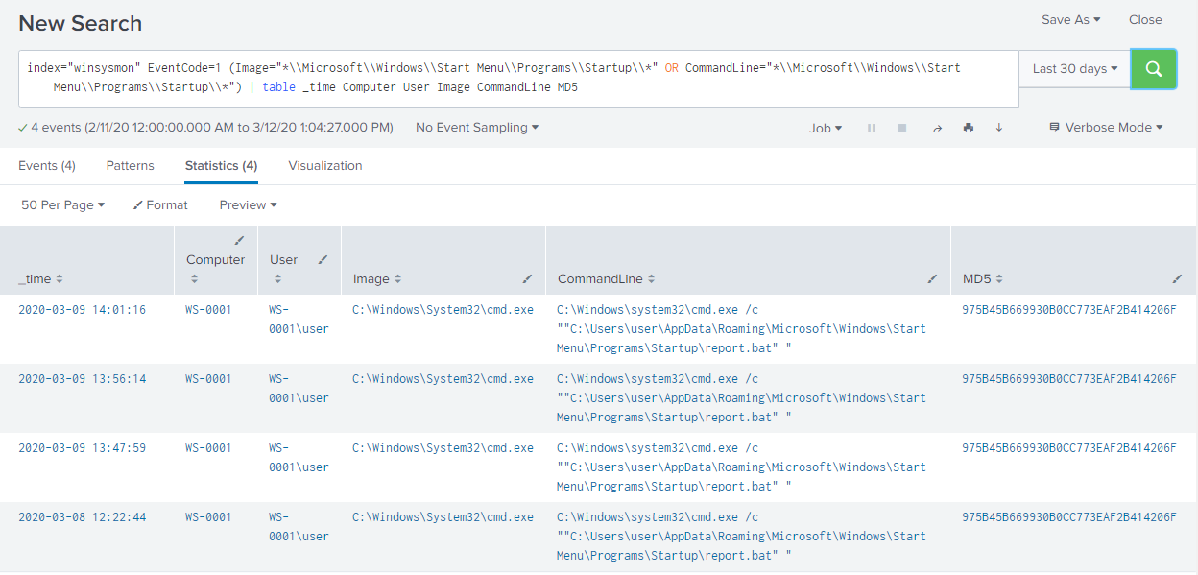
We discover that a batch script has been executed multiple times from that locations.

Task 12. Hunt for internal recon
After reviewing the provided resource, we discover a long list of binary files that are commonly used in performing internal recon to gather information. Our hunt will focus on whether 2 or more were executed within a time-frame of 15 minutes. We construct the following query:
index="winsysmon" EventCode=1 Image=*\\ipconfig.exe OR Image=*\\net.exe OR Image=*\\whoami.exe OR Image=*\\netstat.exe OR Image=*\\nbtstat.exe OR Image=*\\hostname.exe OR Image=*\\tasklist.exe | bin _time span=15m | stats dc(Image) AS CNT_CMDS values(CommandLine) values(ParentCommandLine) count by _time Computer User | where CNT_CMDS > 2
Once executed, we get the following output:
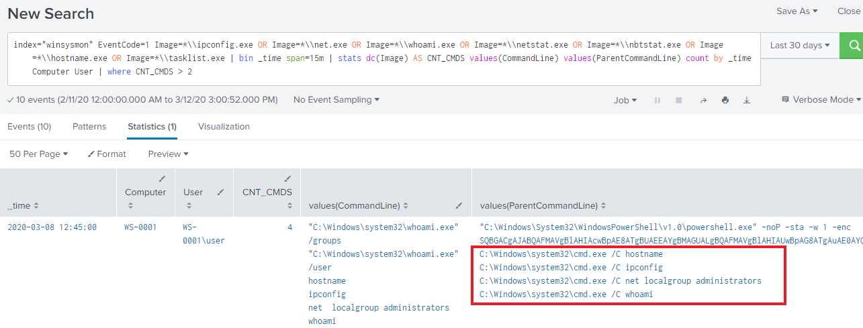

Task 13. Hunt for suspicious VBS scripts
After reviewing the provided resource and additional research, we discover that VBS scripts are executed by cscript.exe or wscript.exe. Using that with Sysmon Event ID 1, we'll search whether those binaries have executed, and if so, what scripts they executed. We construct the following query:
index="winsysmon" EventCode=1 Image="*\\cscript.exe" OR Image="*\\wscript.exe" | rex field=Image ".*\\\\(?<Image_fn>[^\\\\]*)" | rex field=ParentImage ".*\\\\(?<ParentImage_fn>[^\\\\]*)" | stats count by Computer User ProcessId Image CommandLine ParentImage ParentCommandLine
Once executed, we get the following:
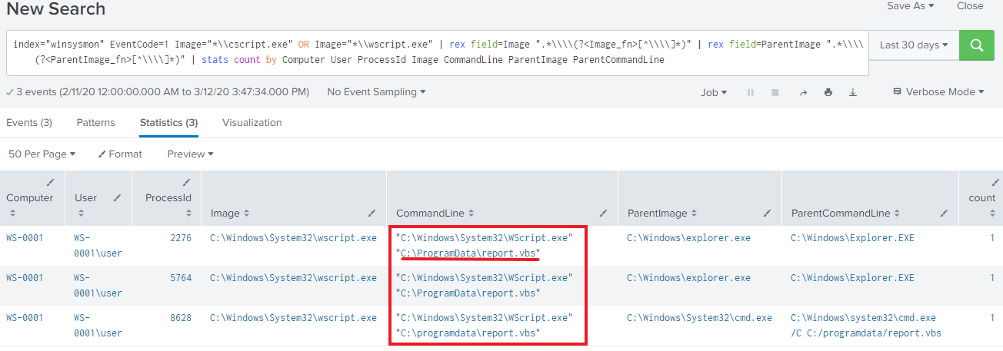
We see that a script was executed running rom %PROGRAMDATA%.

